Odoo – General User Guide

Contents

Purpose 2

Logging In 2

Home Screen 3

Menu Navigation 4

Forms 5

Actions 5

Chatter 5

Follow/Unfollow 5

Send Message 6

Log Note 6

Schedule Activity 7

View Types 8

Kanban 8

List 9

Calendar 9

Pivot 9

Graph 9

Activity 10

Gantt 10

Searching & Viewing Records 10

Filters 11

Group By 11

Favorites 11

Dashboard 12

# Purpose

The purpose of this document is to describe the general usability features of Odoo that work throughout the system. It includes information about how to login, navigate throughout Odoo and describes views, filtering, grouping and other components that are common in the Odoo system.

# Logging In

Odoo can have multiple database instances on the same server. This is useful for testing purposes and as you can see below, our test server has many different databases created for release candidates. The production server will more likely only have one database.

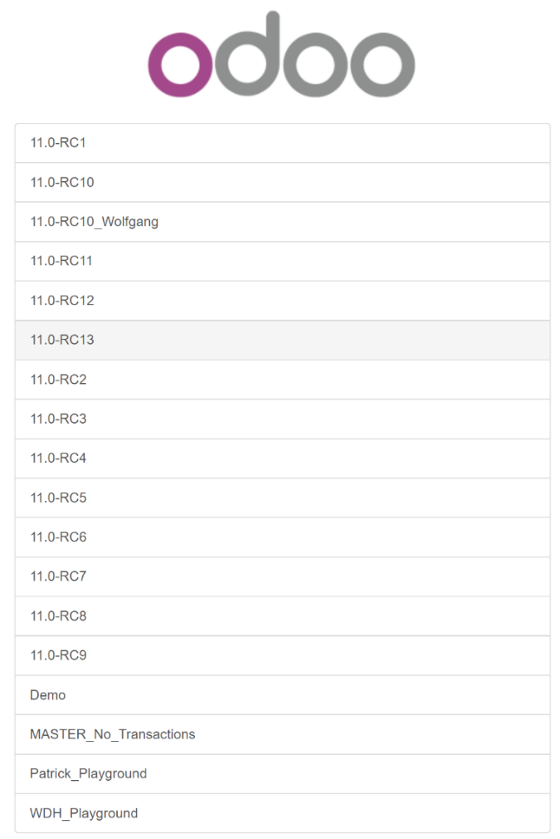

After you select the database to log into, enter your email and password to login. If active directory is enabled, use those credentials to login. **NOTE**: Test servers do not have AD enabled at the time of writing this document.

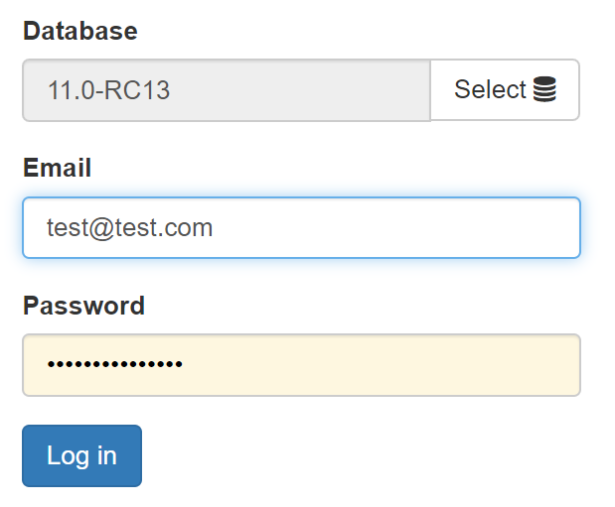

# Home Screen

Once logged in, you will see the home screen that contains all the ‘apps’ that you have permissions to access.

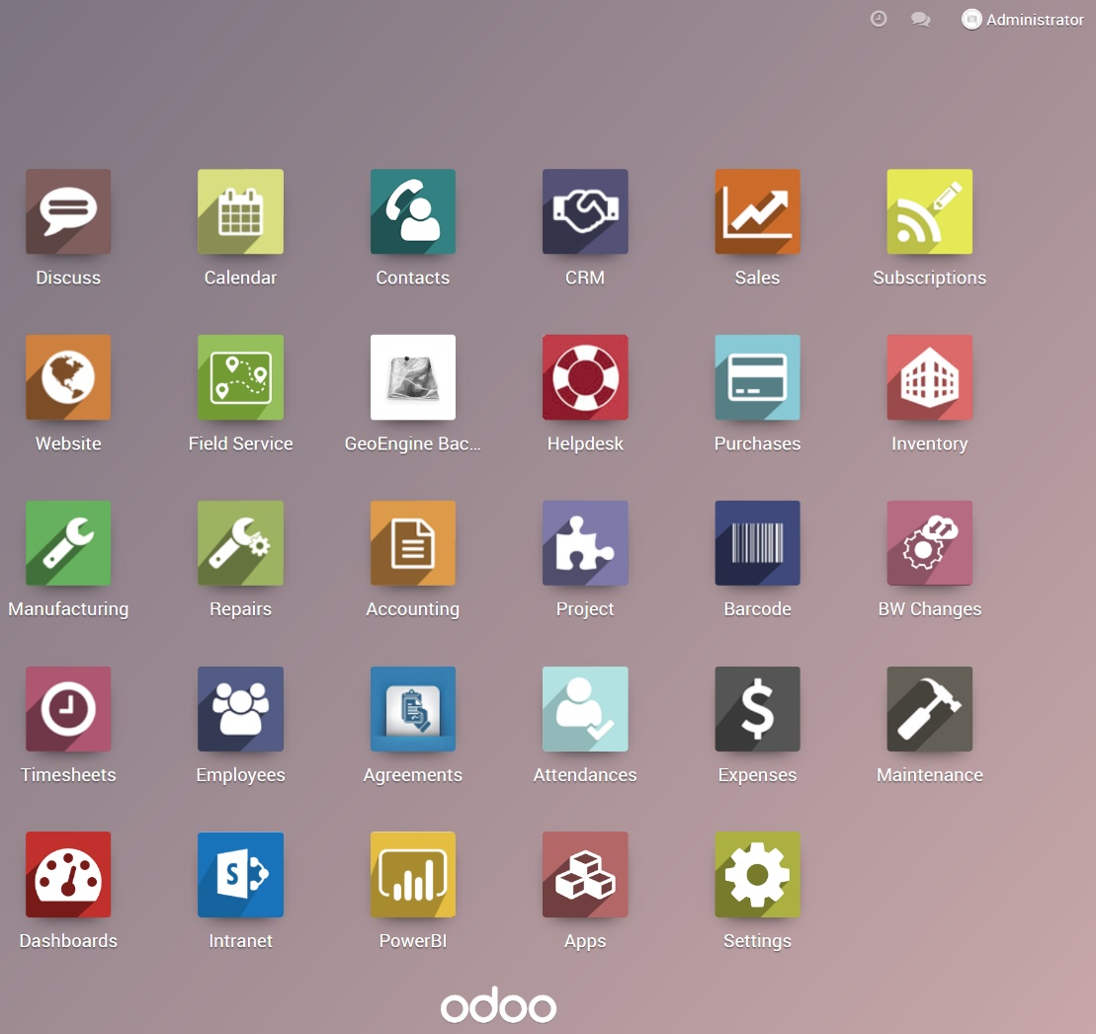

Odoo has a quick search option to find apps or direct access to menus. If you start typing on the home screen, the search bar will become visible. This doesn’t search records, but just apps and menus related to your search text.

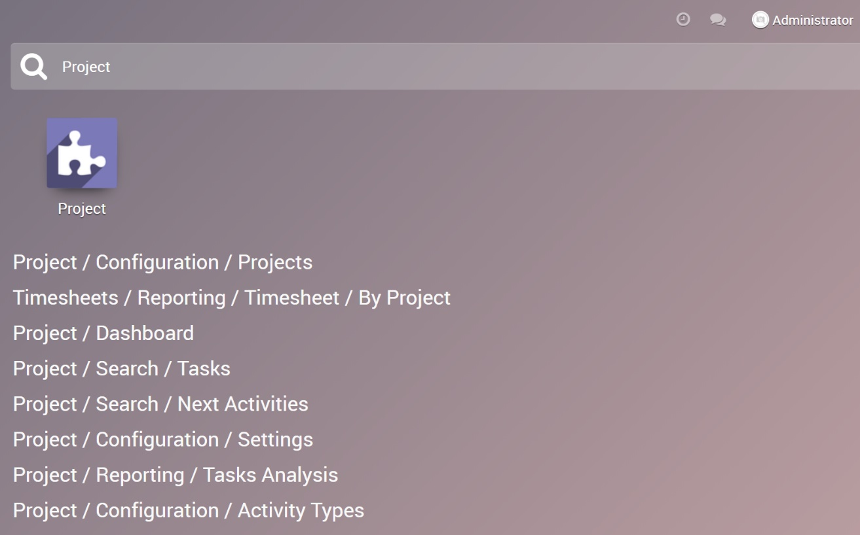

In the top right of the home screen, the clock icon will show any activities you may have.

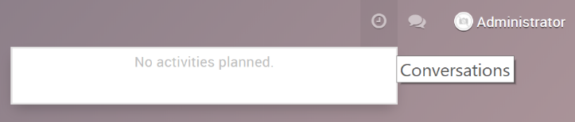

The message icon will show any chat messages that the Discuss app uses, or email messages you may have within Odoo.

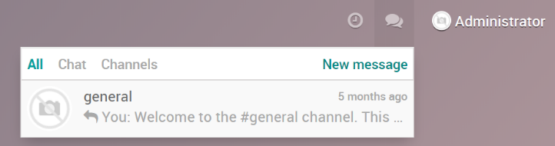

Clicking your name will give additional options to your account.

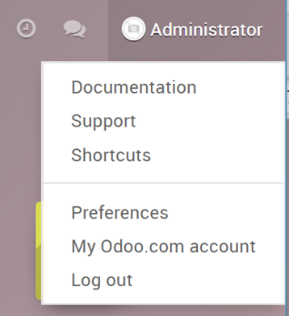

# Menu Navigation

When you open an app, menu items show on the top bar and differ depending on the App. The top left icon will show on all menus and brings you back to the home page. Some menu items will drop down showing a list of additional items, while others may have a direct link to a view.

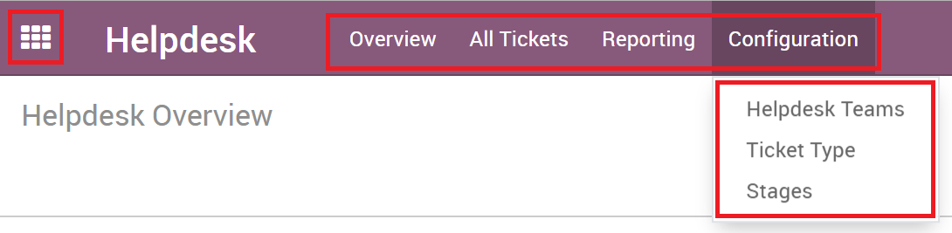

# Forms

When you open a record, a Form opens with all the relevant fields for that record. Forms also contain the stages, typically on top of the form, smart buttons which show whether the record is active or inactive or have counts of related records, and the chatter box which contains all the activities and audit history of the record.

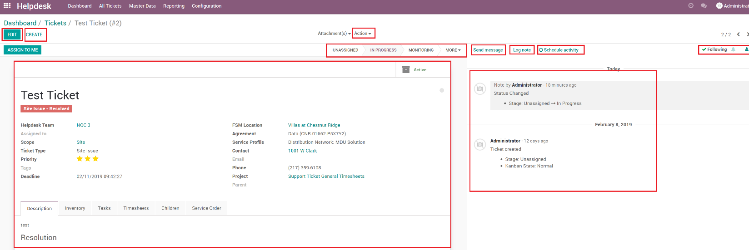

## Actions

Actions are workflows that do a certain thing. Actions show at the top of records and will also list views when records are selected and run a workflow on the record(s). Sometimes it can open a workflow wizard or just do some actions on the record itself.

## Chatter

The Chatter is a powerful feature that allows users to send emails, log notes, or schedule activities. It also contains all the audit history of the record and is where you select followers who can receive notifications through the record changes.

### Follow/Unfollow

Odoo is built with collaboration and communication in mind, and this is done via the Following feature. You can or a contact can Follow any record that has Chatter enabled and will receive updates throughout the record. Followers of a record are managed via the following section in the top right part of the chatter box.

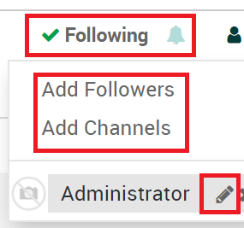

To add followers or channels (Discuss App), you just add them by clicking the person icon and then the Add buttons. You will also see a list of current followers. Clicking the pencil allows you to edit the followers notifications that they will receive.

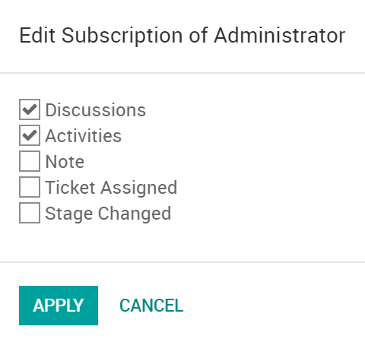

### Send Message

Sending an email is as easy as clicking the send message link. It will automatically add all the followers to the email. Files can be attached as well.

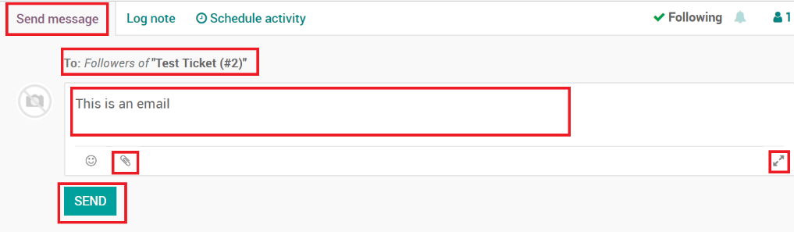

Clicking the Expand Icon will open the full form, where you can change the recipients or use an email template.

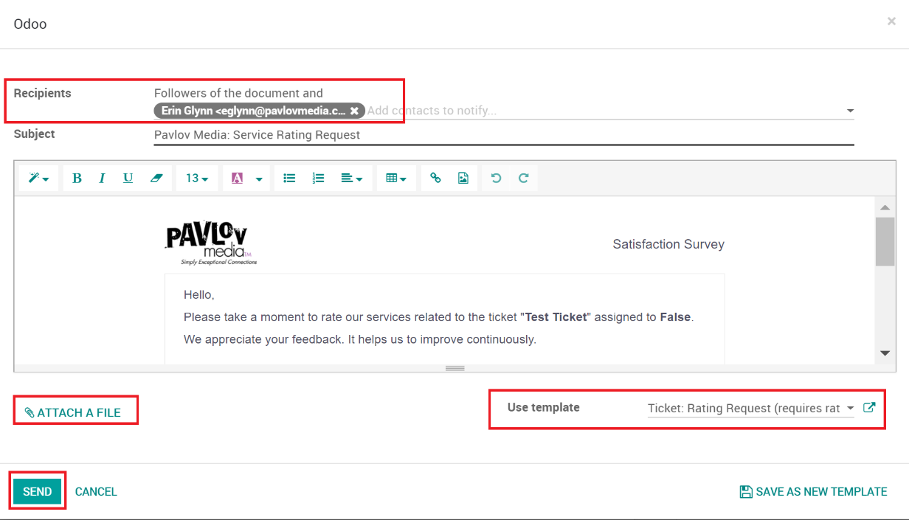

### Log Note

Notes are easy to create by just clicking the Log note link on the Chatter. You can attach files to notes.

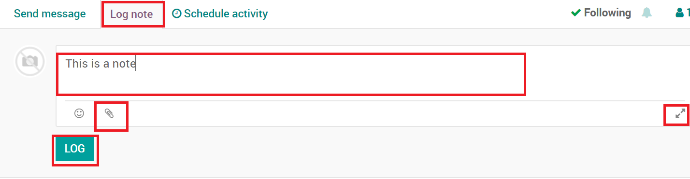

Clicking the Expand Icon will open the full form, where you attach files or use a template (same as email templates).

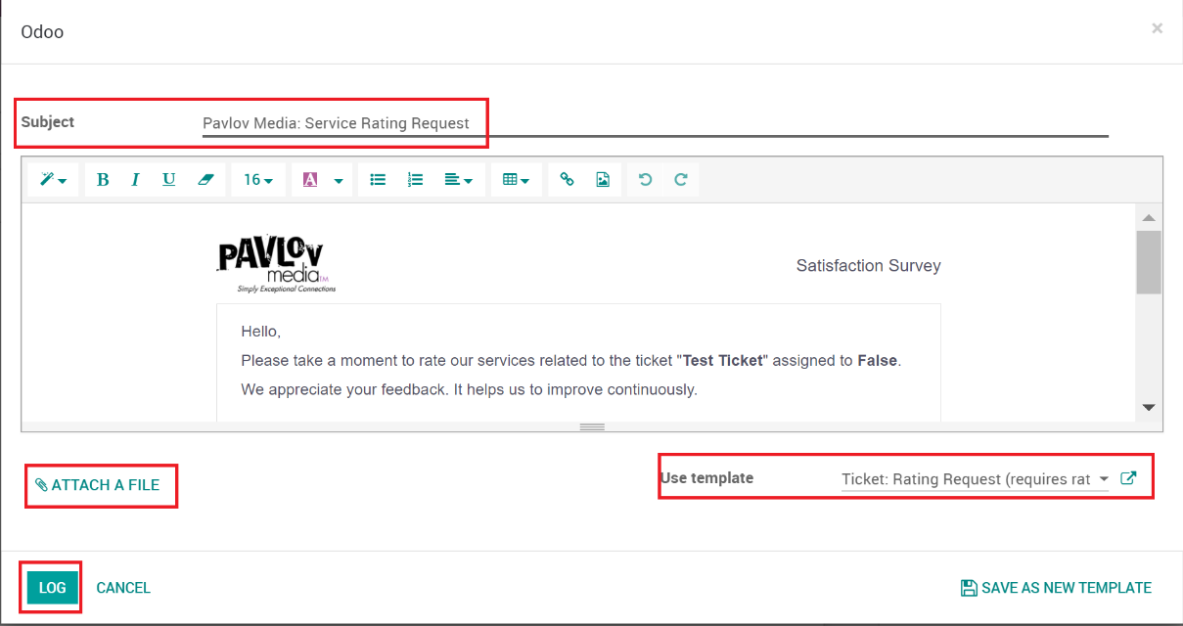

### Schedule Activity

To schedule an activity, click the Schedule Activity link on the Chatter. Activities are scheduled tasks that can be reminders to email, call, meet or a to do task.

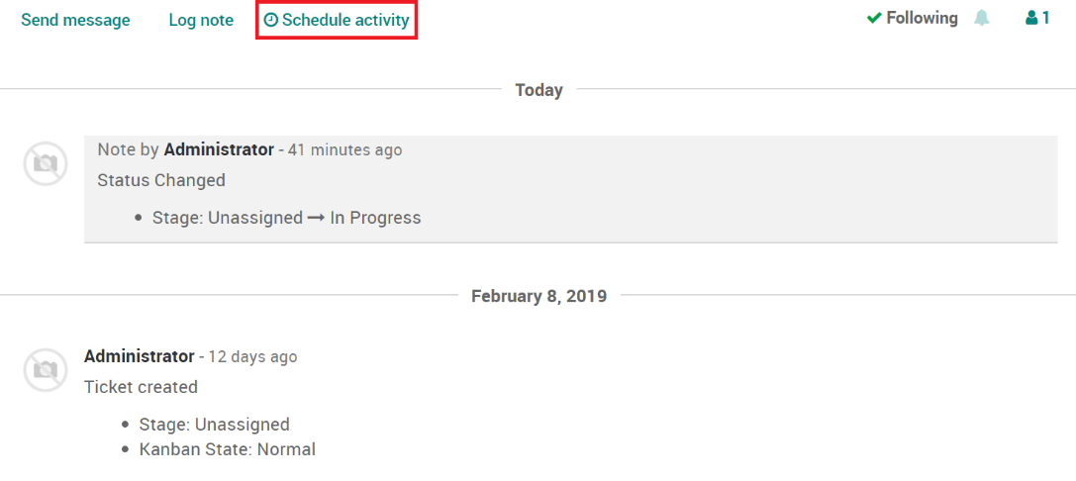

Once you click the Schedule Activity, the form will open to create your activity.

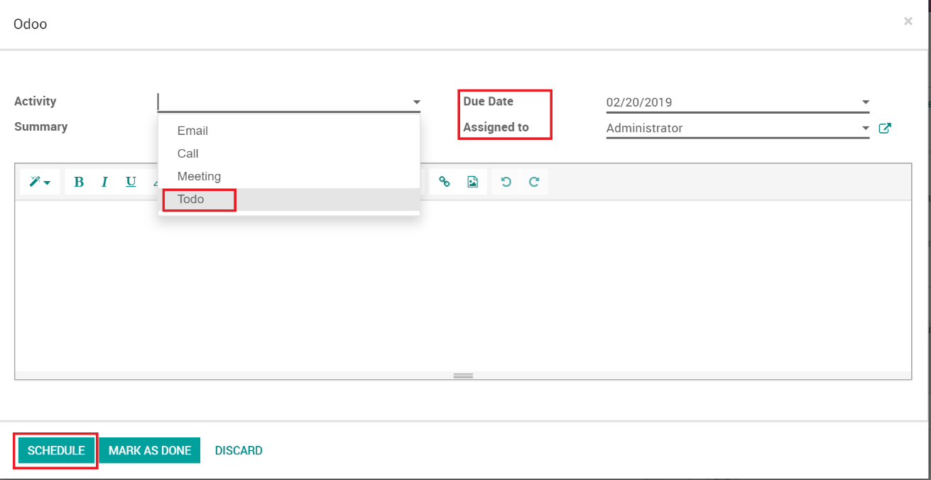

# View Types

There are many different types of views in Odoo that the individual apps use. These views are selectable from the top right area when you open the app. The different icon represents the views.

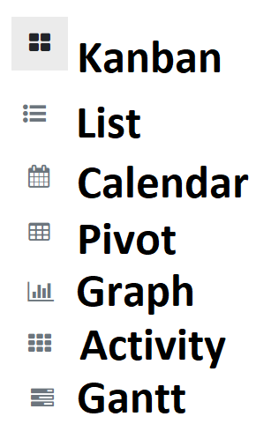

In addition to these views, some custom views are available in the Field Service app, which includes a map view and a Scheduling Gantt view.

## Kanban

The Kanban view contains cards that show information and adds the flexibility to move records from different stages and show a wide range of information. Clicking on the card opens the record.

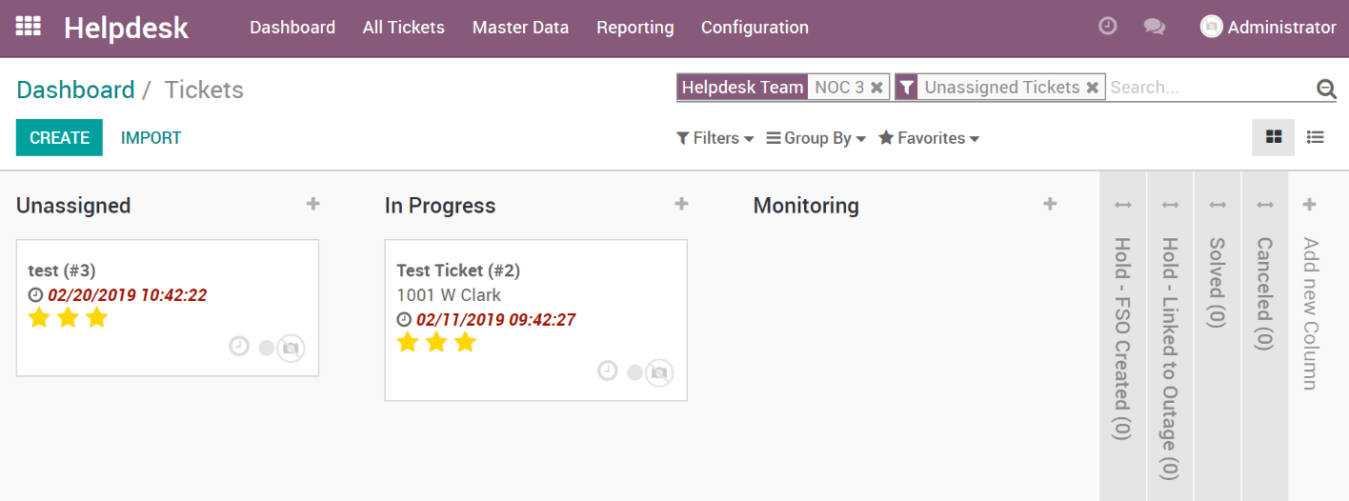

## List

List views show the list of records. These views are useful if a lot of views are needed to be seen at once.

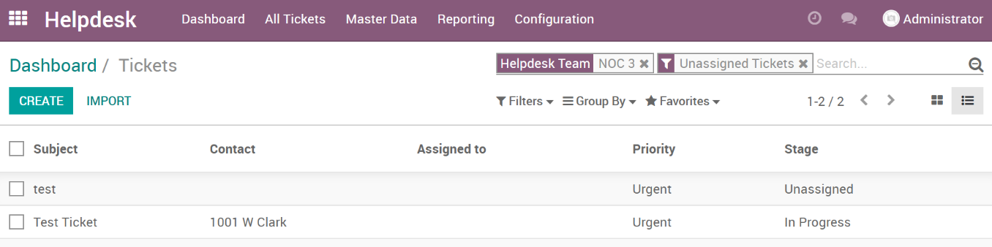

## Calendar

The calendar view shows records on a calendar. Not all items can have a calendar view but ones with dates might have the ability to be shown on a calendar.

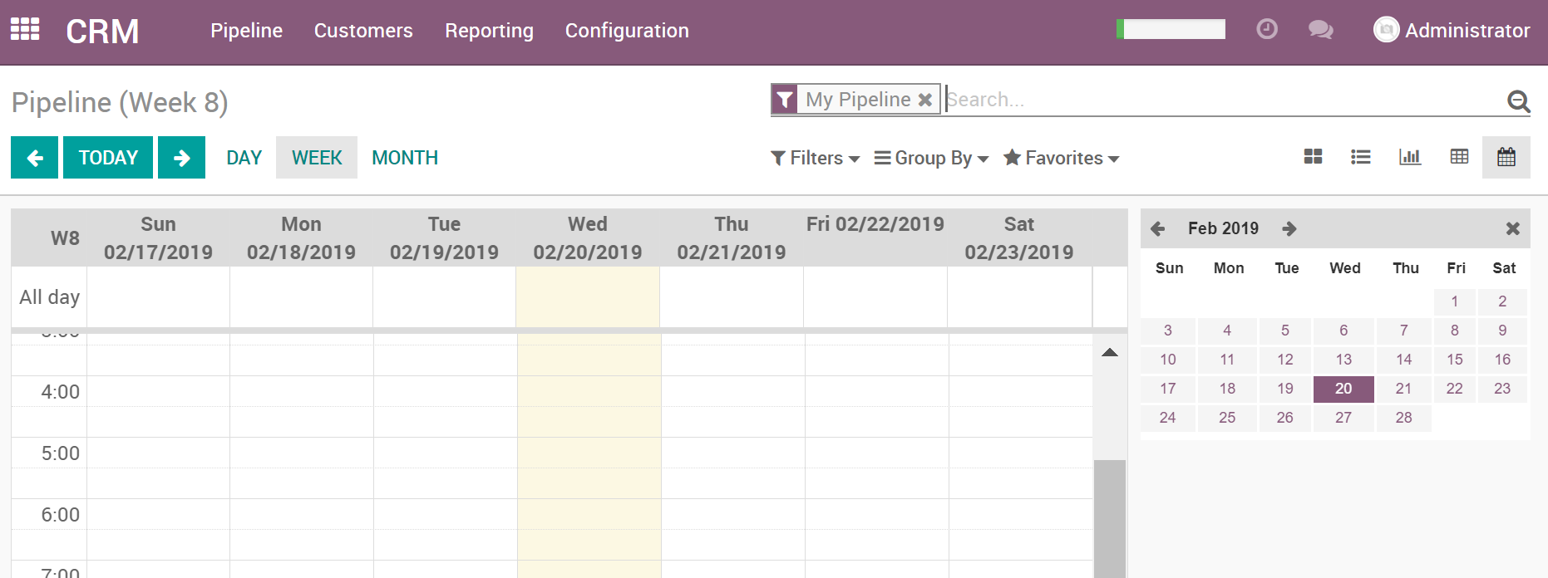

## Pivot

The Pivot view gives you a customizable pivot table to organize data as needed for reporting.

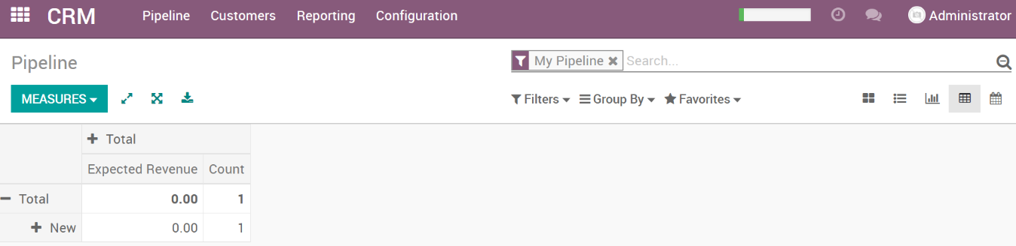

## Graph

Graph views show measures and graphs of the records. You can change the measure and graph type by clicking the top left icons.

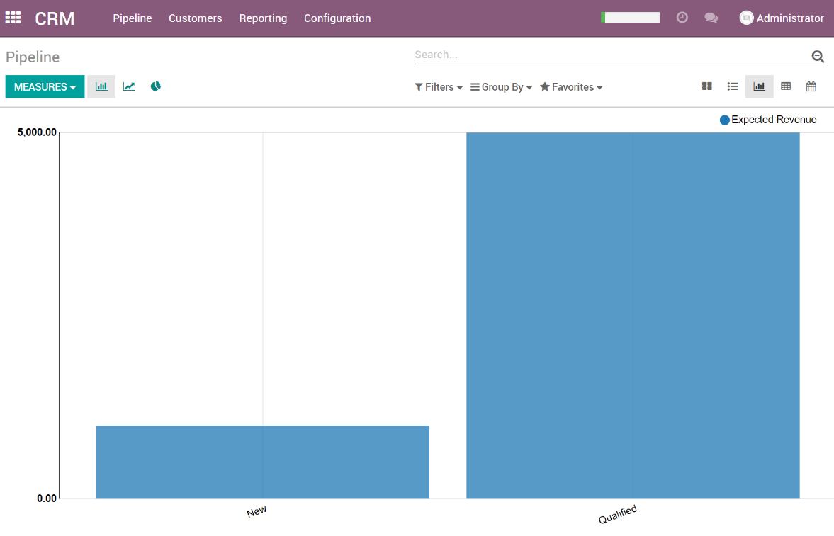

## Activity

This view focuses on activities like phone calls, meetings, to do, etc. When selected it shows the activities and the record they are related to.

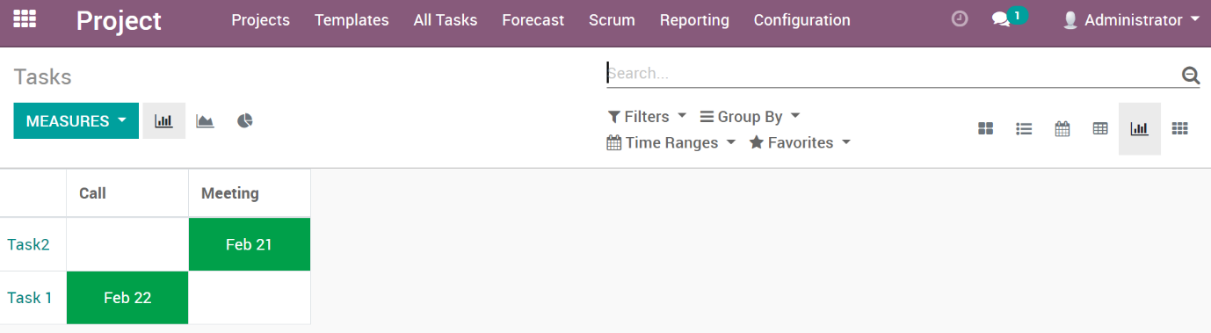

## Gantt

The Gantt view shows a list of records with their start/end dates. The Project Forecasts have a Gantt that has calculations for employee working times and time allocation.

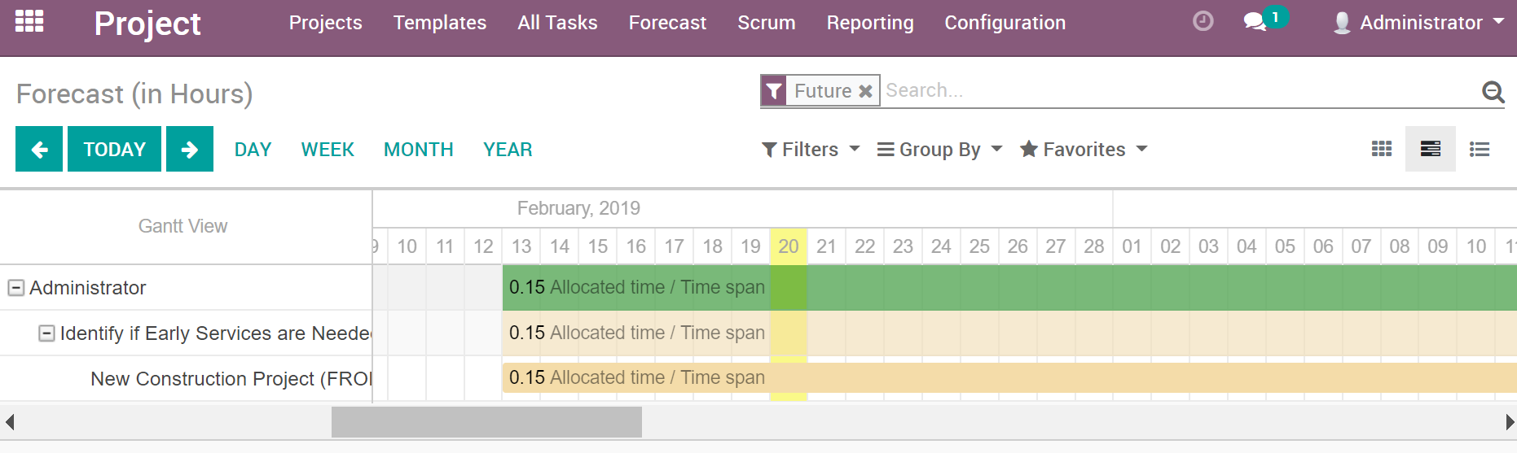

# Searching & Viewing Records

All apps and views can search, sort and group records. When on a view, the top right will show a search area as well as Filters, Group by and Favorites. If the filter area is missing, click the magnifying glass to make that visible. All views can have their records filtered and grouped.

## Filters

Filters give you the ability to filter records. Most Apps already have some of the most common filters, but you can build custom filters. Multiple filters can be applied, and the results are filtered in the order the filter was selected.

Note: When building a custom filter, it won’t save unless you add it to your favorites.

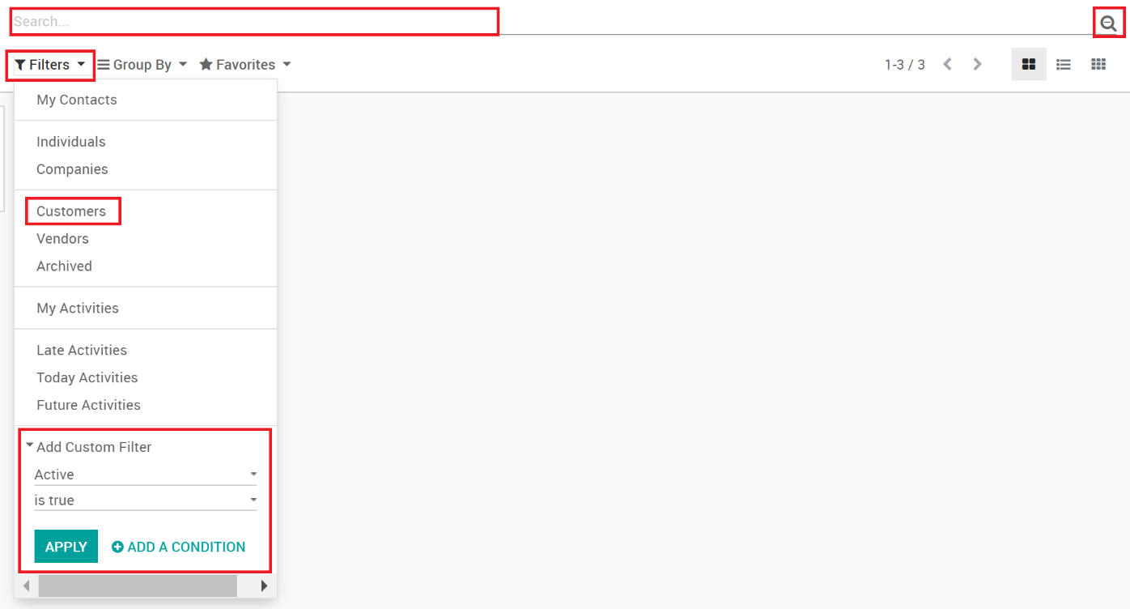

## Group By

Grouping is available to group multiple records together. Most Apps have some common groupings, but you can build custom groups too. Multiple groupings can be applied, and the results are grouped in the order the group was selected.

Note: When building a custom group, it won’t save unless you add it to your favorites.

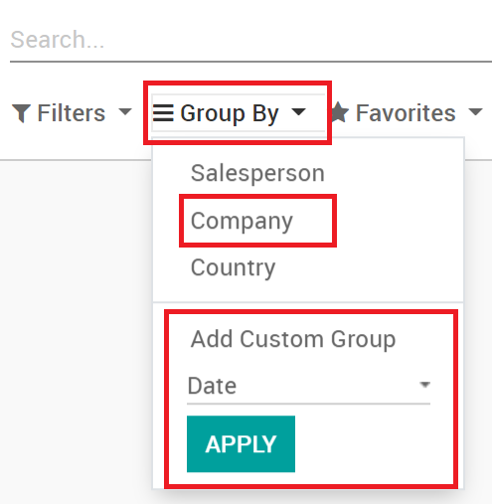

## Favorites

Favorites allow you to save your filtering and grouping settings. Once you’ve set your filters and groups the way you like, you can save your view to be used again later. Clicking on Favorites allows you to name your new filtered view and even set it as the default view whenever you open the app again. Share with all users makes your saved view available to all users.

Note: There isn’t an option to share with specific users.

